**An Android Dev Project Report** **On**

**GROCERY LIST APPLICATION USING KOTLIN IN ANDROID STUDIO**

**SUBMITTED BY:**

**ABBRAR SAIF M**

**UNDER**

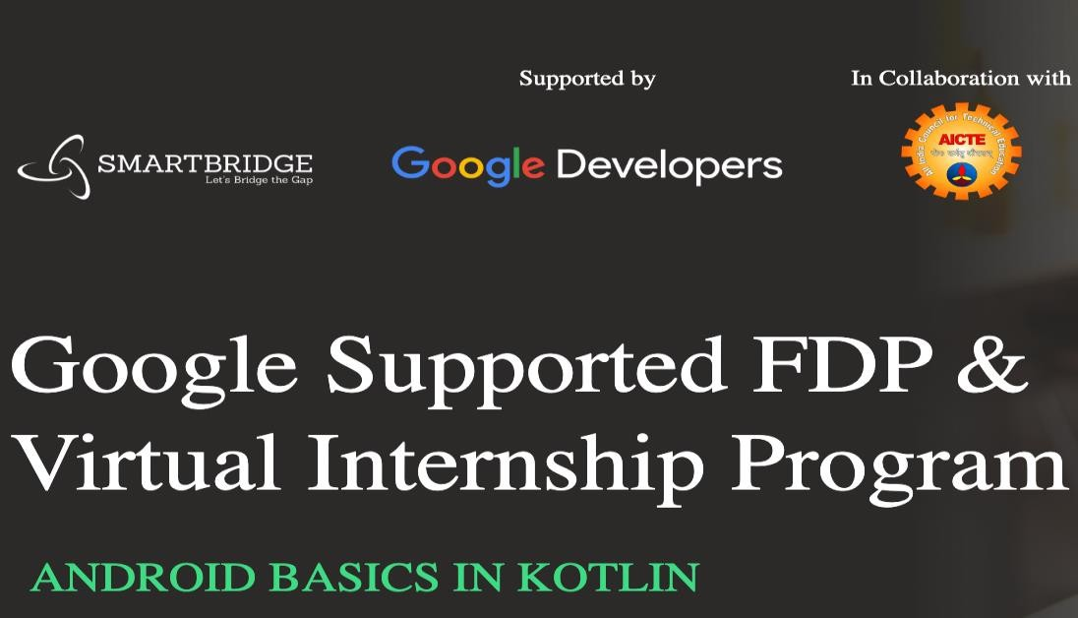

**SPS_APL_20220066528**

Virtual Internship - Android Application

Development Using Kotlin

# INDEX

**CHAPTER 1: Introduction**

* 1. Abstract
  2. Objective
  3. Problem Targeted
  4. Problem’s Primary Goals
  5. Introduction

# CHAPTER 2: Background & Diagrams

* 1. Background
  2. Context Diagram
  3. FlowChart

# CHAPTER 3: Technical Requirements

* 1. Software
  2. Hardware

# CHAPTER 4: Implementation and Designing

* 1. MVVM
  2. ROOM DATABASE
  3. RECYCLERVIEW
  4. COROUTINES
  5. Step 1 to Step 8

# CHAPTER 5: Conclusion and Future Scope

* 1. Expected Outcome
  2. Conclusion & Future Scope
  3. Final Output(Screenshots)
  4. Advantages and Disadvantages
  5. Applications

# CHAPTER 6: URLs, Account IDs and Acknowledgements

6.1 URLs and account id’s

6.2 acknowledgements

# CHAPTER 7: BIBLIOGRAPHY

# 7.1 APPENDIX

# CHAPTER 1: Introduction

* 1. **ABSTRACT**

Shopping is one of the activities that some people consider part of their life, while others do not even think of it. This comparison makes us discover people's problems with shopping. People have shopping problems such as limited time, expats in foreign countries without cars, a transportation issue, people consider physical shopping as a waste of time, health issues, long- distance to market. And the difficulty in obtaining some items.

As the problems mentioned above, we have explored our idea, which is related to personal shopping. Therefore, we have built an application that combines different market shops, i.e. (Malls, supermarkets, and pharmacies).

This personal grocery shopping is an innovative app that allows the customers to get all their needs and suggest items based on previous history. Then deliver items to their doorstep and can facilitate online shopping procedure where customers can browse unlimited products all at one time. This work supports people in exploiting their time to be safer and more accessible than wasting it physically.

Moreover, people can order the product from home instead of going around for long distances for shopping. In addition, this app could help people who are facing health problems and unable to buy something physically to avoid future problems.

Finally, some people do not have transportation methods for shopping, and they should keep pace with the evolution.

# OBJECTIVE

The main aim of this project is to list the items so that whenever users go to grocery stores, users will not be able to forget their items and this grocery application helps the users to tackle their day to day chaos more effortlessly.

# PROBLEM TARGETED

It’s not easy for the users to remember every item in this hectic lifestyle, they frequently can’t recall their required necessity so we decided to build an app to store the items in the database for their future use. After buying the items users can delete the added items in the database.

# PROBLEM’S PRIMARY GOALS

The goal of this project is to make an app that stores the user items in a cart and can modify and delete the added item in the list. To develop a reliable system, I have some specific goals such as:

* + - Develop a system such that users can add item details like product name, product Quantity, and Product Price.
    - Develop a database room that is used to store the user data which already been added by the user in the cart and the user can also remove the previously added item in the cart.
    - Develop a good UI design that user friendly to the user.
    - Develop a good UI that is supported for all android devices.

# INTRODUCTION

We are going to build a grocery application in android using Android Studio. Many times we forget to purchase things that we want to buy, after all, we can’t remember all the items, so with the help of this app, you can note down your grocery items that you are going to purchase, by doing this you can’t forget any items that you want to purchase. In this project, we are using (MVVM) for architectural patterns, Room for database, Recycler View and Coroutines to display the list of items.

# CHAPTER 2: Background & Diagrams

* 1. **BACKGROUND**

The grocery cart application project will help the user or admin to store the list of items in proper sequence. User/Admin can add and remove the items in the list according to his/her will.

* + - UI DESIGN IN THE ANDROID PLATFORM
    - ANDROID APPLICATION DEVELOPMENT
    - DATABASE CONNECTION TO STORE USER DATA

# CONTEXT DIAGRAM

**Enter the item names to Grocery DB**

**Add the Items to Grocery DB**

**Delete the Items from the Grocery DB**

# FLOW DIAGRAM

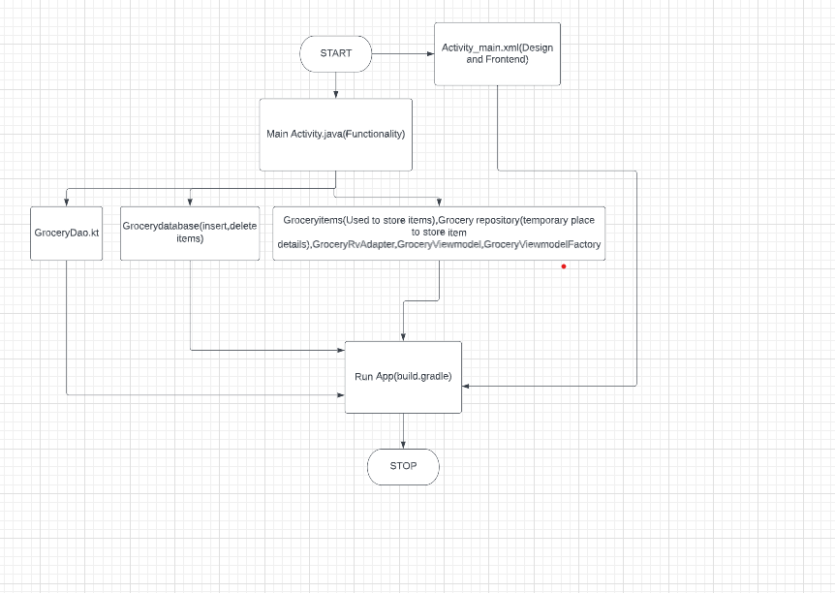

**CHAPTER 3: Technical Requirements**

# SOFTWARE

The Software Package is developed using Kotlin and Android Studio, basic SQL commands are used to store the database.

Operating System: Windows 11 Software: Kotlin and Java

Emulator: Pixel 4 API 30

# HARDWARE

RAM: 8 GB RAM

ROM: 20 GB ROM

# CHAPTER 4: Implementation and Designing

In this project, we are using [MVVM (Model View ViewModel)](https://www.geeksforgeeks.org/introduction-to-model-view-view-model-mvvm/) for architectural patterns, **Room** for database, [Coroutines](https://www.geeksforgeeks.org/kotlin-coroutines-on-android/) and [RecyclerView](https://www.geeksforgeeks.org/android-recyclerview/) to display the list of items.

# MVVM (Model View ViewModel)

MVVM architecture in android is used to give structure to the project’s code and understand code easily. MVVM is an architectural design pattern in android. MVVM treat Activity classes and XML files as View. This design pattern completely separate UI from its logic. Here is an image to quickly understand MVVM.

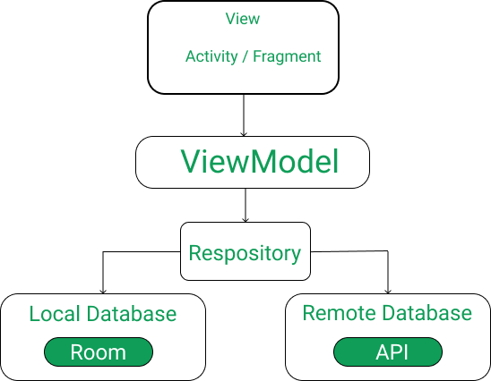

# ROOM Database

Room persistence library is a database management library and it is used to store the data of apps like grocery item name, grocery item quantity, and grocery item price. Room is a cover layer on [SQLite](https://www.geeksforgeeks.org/introduction-to-sqlite/) which helps to perform the operation on the database easily.

# RecycleView

RecyclerView is a container and it is used to display the collection of data in a large amount of data set that can be scrolled very effectively by maintaining a limited number of views.

# Coroutines

Coroutines are a lightweight thread, we use coroutines to perform an operation on other threads, by this our main thread doesn’t block and our app doesn’t crash.

# Step By Step Process Step 1: Create a New Project

To create a new project in Android Studio please refer to [How to Create/Start a New Project in](https://www.geeksforgeeks.org/android-how-to-create-start-a-new-project-in-android-studio/)

[Android Studio.](https://www.geeksforgeeks.org/android-how-to-create-start-a-new-project-in-android-studio/) Note that select **Kotlin** as the programming language.

# Step 2: Before going to the coding section first you have to do some pre-task

Before going to the coding part first add these libraries in your [gradle file](https://www.geeksforgeeks.org/android-build-gradle/) and also apply the plugin as ‘kotlin-kapt’. To add these library go to **Gradle Scripts > build.gradle (Module: app)**.

# Step 3: Implement Room Database

* + 1. **Entities class**

The entities class contains all the columns in the database and it should be annotated with @Entity (tablename = “Name of table”). Entity class is a data class. And @Column info annotation is used to enter column variable name and datatype. We will also add Primary Key for auto-increment. Go to **app > java > com.example.application-name.** Right-click on **com.example.application-name** go to new and create Kotlin file/class and name the file as **GroceryEntities**. See the code below to completely understand and implement.

# DAO Interface

The DAO is an interface in which we create all the functions that we want to implement on the database. This interface also annotated with @Dao. Now we will create a function using [suspend function](https://www.geeksforgeeks.org/suspend-function-in-kotlin-coroutines/) which is a coroutines function. Here we create three functions, First is the insert function to insert items in the database and annotated with @Insert, Second is for deleting items from the database annotated with @Delete and Third is for getting all items annotated with @Query. Go to the **app > java > com.example.application-name**. Right- click on **com.example.application-name** go to new and create Kotlin file/class and name the file as **GroceryDao**. See the code below to implement.

# Database class

Database class annotated with @Database(entities = [Name of Entity class.class], version = 1) these entities are the entities array list all the data entities associating with the database and version shows the current version of the database. This database class inherits from the Room Database class. In **GroceryDatabase** class we will make an abstract method to get an instance of DAO and further use this method from the DAO instance to interact with the database. Go to the **app > java > com.example.application-name**. Right-click

on **com.example.application-name** go to new and create Kotlin file/class as **GroceryDatabase**.

# Step 4: Now we will implement the Architectural Structure in the App

1. **Repository Cla**ss

The repository is one of the design structures. The repository class gives the data to the ViewModel class and then the ViewModel class uses that data for Views. The repository will choose the appropriate data locally or on the network. Here in our Grocery Repository class data fetch locally from the Room database. We will add constructor value by creating an instance of the database and stored in the db variable in the Grocery Repository class. Go to the **app > java > com.example.application-name**. Right-click

on **com.example.application-name** go to new and create Kotlin file/class

as **GroceryRepository**. Go to **app > java > com.example.application-name**. Right-click on **com.example.application-name** go to new and create a new Package called **UI** and then right-click on UI package and create a Kotlin file/class.

# ViewModel Class

ViewModel class used as an interface between View and Data. Grocery View Model class inherit from View Model class and we will pass constructor value by creating instance variable of Repository class and stored in repository variable. As we pass the constructor in View Model we have to create another class which is a Factory View Model class. Go

to **app > java > com.example.application-name > UI**. Right-click on the UI package and create a Kotlin file/class and name the file as **GroceryViewModel**.

# FactoryViewModel Class

We will inherit the Grocery ViewModel Factory class from ViewModelProvider. NewInstanceFactory and again pass constructor value by creating instance variable of GroceryRepository and return GroceryViewModel (repository). Go to the **app > java > com.example.application-name > UI**. Right-click on the **UI** package and create a Kotlin file/class name it **GroceryViewModelFactory**.

# Step 5: Now let’s jump into the UI part

In the **activity_main.xml** file, we will add two [ImageView,](https://www.geeksforgeeks.org/imageview-in-kotlin/) [RecyclerView,](https://www.geeksforgeeks.org/android-recyclerview/) and [Button](https://www.geeksforgeeks.org/button-in-kotlin/) after clicking this button a **DialogBox** open and in that dialog box user can enter the item name, item quantity, and item price.

# Step 6:

Let’s implement **RecyclerView**. Now we will code the UI part of the row in the list. Go to **app**

**> res > layout**. Right-click on layout, go to new, and then add a **Layout Resource File** and name it as **GroceryAdapter**.We will code adapter class for recycler view. In the GroceryAdapter class, we will add constructor value by storing entities class as a list in list variable and create an instance of the view model. In Grocery Adapter we will override three functions: onCreateViewHolder, getItemCount, and onbindViewHolder, we will also create an inner class called grocery view holder. Go to the **app > java > com.example.application- name**. Right-click on **com.example.application-name** go to new and create a new Package called **Adapter** and then right-click on Adapter package and create a Kotlin file/class name

it **GroceryAdapter**.

# Step 7:

To enter grocery item, quantity, and price from the user we have to create an interface. To implement this interface we will use DialogBox. First create UI of dialog box. In this dialog box we will add three edit text and two text view. Three edit text to enter grocery item name, quantity and price. Two text view one for save and other for cancel. After clicking the save text all data saved into the database and by clicking on the cancel text dialog box closes. Go to

the **app > res > layout**. Right-click on **layout**, go to new and then add a **Layout Resource File** and name it as **GroceryDialog**. To add a clicklistener on save text we have to create an

interface first in which we create a function. Go to the **app > java > com.example.application- name > UI.** Right-click on the **UI** package and create a Kotlin file/class and create

an **interface** name it as **DialogListener**.

# Step 8:

In this final step we will code in our **MainActivity**. In our **MainActivity**, we have to set up the recycler view and add click listener on add button to open the dialog box.

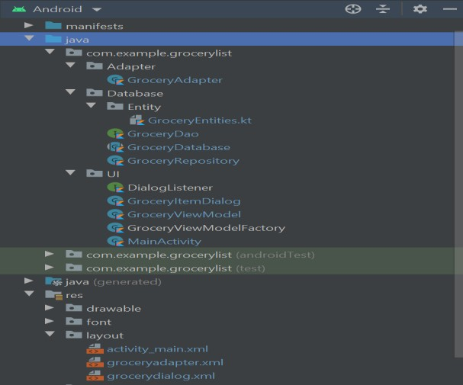

**Complete Project Structure**

# CHAPTER 5: Conclusion and Future Scope 5.1 Expected Outcome

The app can help the individuals to note down the list of

items to be purchased and stores in remote database.It

uses MVVM architecture.

# Conclusion & Future Scope

This grocery application will help to store the list of data items include name of item, price and quantity required. Admins store his/her data in the list, the grocery application very helpful to users.

# Future Scope:

This application helps to store the list of items by Admin. In Future we can also add scheduled addition of items according to requirement of user.

The Features are:

* + - Add User Panel
    - Add Admin Panel
    - Provide Login Authentication
    - Add Image to user Product and Rating
  1. **Final Output(Screenshots)**

1. **APP ICON:**

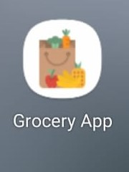

**ii) ADDING AN ITEM:**

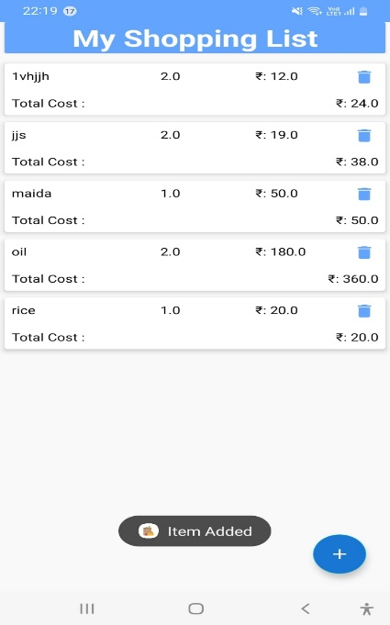

**iii)DELETING AN ITEM**

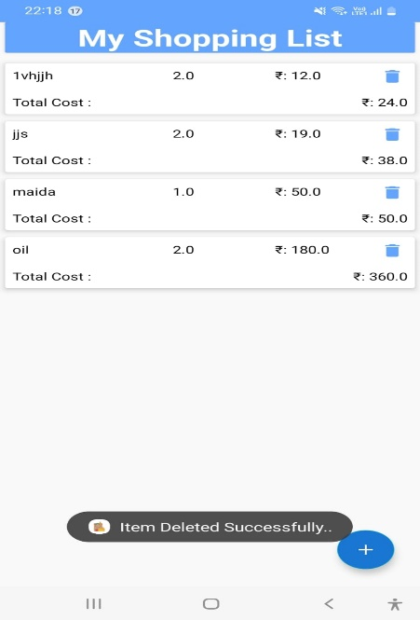

* 1. **ADVANTAGES AND DISADVANTAGES**

**ADVANTAGES:**

* Dynamic oriented.
* Easy usage(can be used by a novice).
* Interactive UI.

**DISADVANTAGES:**

* Less images and description being used.
* Design implementation must be focused.

* 1. **APPLICATIONS**
* Can be used to store the provision list of groceries.
* Also it can be used as TO DO LIST for a set of jobs to be completed.

# CHAPTER 6: URLs, GitHub URL, Account IDs and Acknowledgements 6.1 URLs & Account Ids

**GitHub URL:**

<https://github.com/smartinternz02/SPSGP-58412-Virtual-Internship---Android-Application-Development-Using-Kotlin>

# Demo Link:

# <https://drive.google.com/file/d/1e0mnncENkv-60OsBorUtUXw2wn-dh-od/view?usp=sharing>

**Smart Internz Registered ID: SPS_APL_20220066528**

**Registered Mail ID**:[mabbrarsaif19@gmail.com](mailto:mabbrarsaif19@gmail.com)

**6.2 Acknowledgements**

I have taken much efforts in this project. However, it would not have been possible without the kind support and help of many individuals and organizations. I would like to extend my sincere thanks to all of them.

I am highly indebted to SMARTINTERNZ (Experiential Learning & Remote Externship Platform to bring academia & industry very close for a common goal of talent creation) for their guidance and constant supervision as well as for providing necessary information regarding the

project & also for their support in completing the project. I would like to express my gratitude

towards member of (Smart Internz) for their kind co-operation and encouragement which help me

in completion of this project.

I would like to express my special gratitude and thanks to industry persons for giving me such attention and time.

My thanks and appreciations also go to people who have willingly helped me out with their abilities.

# CHAPTER 7: BIBLIOGRAPHY

* <https://youtu.be/5YmJLB8f3W0>
* <https://github.com/divyanshu15/GroceryApp>
* <https://www.youtube.com/watch?v=vdcLb_Y71Ic>
* <https://www.geeksforgeeks.org/introduction-to-kotlin>

**APPENDIX**

1. **MainActivity.kt**

package com.saif.groceryapp  
  
import android.app.Dialog  
import androidx.appcompat.app.AppCompatActivity  
import android.os.Bundle  
import android.widget.EditText  
import android.widget.Toast  
import androidx.appcompat.widget.AppCompatButton  
import androidx.lifecycle.Observer  
import androidx.lifecycle.ViewModelProvider  
import androidx.recyclerview.widget.LinearLayoutManager  
import androidx.recyclerview.widget.RecyclerView  
import com.divyanshu.groceryapp.R  
import com.google.android.material.floatingactionbutton.FloatingActionButton  
  
class MainActivity : AppCompatActivity(),GroceryRVAdapter.GroceryItemClickInterface {  
 lateinit var itemRV:RecyclerView  
 lateinit var addFAB:FloatingActionButton  
 lateinit var list: List<GroceryItems>  
 lateinit var groceryRVAdapter: GroceryRVAdapter  
 lateinit var groceryViewModel: GroceryViewModel  
 override fun onCreate(savedInstanceState: Bundle?) {  
 super.onCreate(savedInstanceState)  
 setContentView(R.layout.*activity_main*)  
 itemRV = findViewById(R.id.*rvitems*)  
 addFAB = findViewById(R.id.*fabAdd*)  
 list = ArrayList<GroceryItems>()  
 groceryRVAdapter = GroceryRVAdapter(list,this)  
 itemRV.*layoutManager* = LinearLayoutManager(this)  
 itemRV.*adapter* = groceryRVAdapter  
 val groceryRepository = GroceryRepository(GroceryDatabase(this))  
 val factory = GroceryViewModelFactory(groceryRepository)  
 groceryViewModel = ViewModelProvider(this,factory).get(GroceryViewModel::class.*java*)  
 groceryViewModel.getAllGroceryItems().observe(this, *Observer* **{** groceryRVAdapter.list = **it** groceryRVAdapter.notifyDataSetChanged()  
 **}**)  
 addFAB.setOnClickListener**{** openDialog()  
 **}** }  
 fun openDialog(){  
 val dialog = Dialog(this)  
 dialog.setContentView(R.layout.*grocery_add_dialog*)  
 val cancelbtn = dialog.findViewById<AppCompatButton>(R.id.*idbtncancel*)  
 val addbtn = dialog.findViewById<AppCompatButton>(R.id.*idbtnadd*)  
 val itemEdt = dialog.findViewById<EditText>(R.id.*idEdtitemname*)  
 val itemPriceEdt = dialog.findViewById<EditText>(R.id.*idEdtitemprice*)  
 val itemQuantityEdt = dialog.findViewById<EditText>(R.id.*idEdtitemquantity*)  
 cancelbtn.setOnClickListener **{** dialog.dismiss()  
 **}** addbtn.setOnClickListener **{** val itemname:String = itemEdt.*text*.toString()  
 val itemprice:String = itemPriceEdt.*text*.toString()  
 val itemquantity:String = itemQuantityEdt.*text*.toString()  
 val qty : Double = itemquantity.*toDouble*()  
 val pr : Double = itemprice.*toDouble*()  
 if (itemname.*isNotEmpty*() && itemprice.*isNotEmpty*() && itemquantity.*isNotEmpty*()){  
 val items = GroceryItems(itemname,qty,pr)  
 groceryViewModel.insert(items)  
 Toast.makeText(*applicationContext*,"Item Added",Toast.*LENGTH_SHORT*).show()  
 groceryRVAdapter.notifyDataSetChanged()  
 dialog.dismiss()  
 }  
 else{  
 Toast.makeText(*applicationContext*,"Please fill all details",Toast.*LENGTH_SHORT*).show()  
 }  
  
 **}** dialog.show()  
 }  
  
 override fun onItemClick(groceryItems: GroceryItems) {  
 groceryViewModel.delete(groceryItems)  
 groceryRVAdapter.notifyDataSetChanged()  
 Toast.makeText(*applicationContext*,"Item Deleted Successfully..",Toast.*LENGTH_SHORT*).show()  
 }  
}

**2.GroceryDao.kt**

package com.saif.groceryapp  
  
import androidx.lifecycle.LiveData  
import androidx.room.*  
  
@Dao  
  
interface GroceryDao {  
 @Insert(onConflict = OnConflictStrategy.*REPLACE*)  
 suspend fun insert(item: GroceryItems)  
 @Delete  
 suspend fun delete(item: GroceryItems)  
 @Query("SELECT * FROM Grocery_items")  
 fun getAllGroceryItems(): LiveData<List<GroceryItems>>  
  
  
}

**3.Activity_main.xml**

<?xml version="1.0" encoding="utf-8"?>  
<RelativeLayout xmlns:android="http://schemas.android.com/apk/res/android"  
 xmlns:app="http://schemas.android.com/apk/res-auto"  
 xmlns:tools="http://schemas.android.com/tools"  
 android:layout_width="match_parent"  
 android:background="#F9F9F9"  
 android:layout_height="match_parent"  
 tools:context=".MainActivity">  
 <androidx.cardview.widget.CardView  
 android:layout_width="match_parent"  
 android:layout_height="wrap_content"  
 android:layout_marginLeft="5dp"  
 android:layout_marginRight="5dp"  
 android:layout_marginBottom="10dp"  
 android:background="@drawable/header_bg"  
 android:backgroundTint="@color/blue_light"  
 android:id="@+id/header"  
 >  
 <TextView  
 android:layout_width="match_parent"  
 android:layout_height="wrap_content"  
 android:text="My Shopping List"  
 android:gravity="center"  
 android:textAlignment="center"  
 android:textSize="30sp"  
 android:textStyle="bold"  
 android:textColor="@color/white"/>  
 </androidx.cardview.widget.CardView>  
  
 <androidx.recyclerview.widget.RecyclerView  
 android:id="@+id/rvitems"  
 android:layout_width="match_parent"  
 android:layout_height="match_parent"  
 android:layout_below="@id/header"  
 tools:listitem="@layout/grocery_rv_item">  
  
 </androidx.recyclerview.widget.RecyclerView>  
  
 <com.google.android.material.floatingactionbutton.FloatingActionButton  
 android:id="@+id/fabAdd"  
 android:layout_width="wrap_content"  
 android:layout_height="wrap_content"  
 android:layout_alignParentEnd="true"  
 android:layout_alignParentBottom="true"  
 android:layout_marginStart="25dp"  
 android:layout_marginTop="25dp"  
 android:layout_marginEnd="25dp"  
 android:layout_marginBottom="25dp"  
 android:backgroundTint="@color/blue"  
 android:elevation="5dp"  
 android:src="@drawable/ic_baseline_add"  
 app:tint="@color/white" />  
  
  
</RelativeLayout>

**4.AndroidManifest.xml**

<?xml version="1.0" encoding="utf-8"?>  
<manifest xmlns:android="http://schemas.android.com/apk/res/android"  
 xmlns:tools="http://schemas.android.com/tools"  
 package="com.saif.groceryapp">  
  
 <application  
 android:allowBackup="true"  
 android:dataExtractionRules="@xml/data_extraction_rules"  
 android:fullBackupContent="@xml/backup_rules"  
 android:icon="@drawable/shopping"  
 android:label="@string/app_name"  
 android:roundIcon="@drawable/shopping"  
 android:supportsRtl="true"  
 android:theme="@style/Theme.GroceryApp"  
 tools:targetApi="31">  
 <activity  
 android:name="com.saif.groceryapp.MainActivity"  
 android:exported="true">  
 <intent-filter>  
 <action android:name="android.intent.action.MAIN" />  
  
 <category android:name="android.intent.category.LAUNCHER" />  
 </intent-filter>  
 </activity>  
 </application>  
  
</manifest>

**5.GroceryDatabase.kt**

package com.saif.groceryapp  
  
import android.content.Context  
import androidx.room.Database  
import androidx.room.Room  
import androidx.room.RoomDatabase  
  
  
@Database(entities = [GroceryItems::class], version = 1)  
  
abstract class GroceryDatabase : RoomDatabase() {  
  
 abstract fun getGroceryDao() : GroceryDao  
 companion object {  
 @Volatile  
 private var instance: GroceryDatabase? = null  
 private val LOCK = Any()  
  
 operator fun invoke(context: Context) = instance ?: *synchronized*(LOCK) **{** instance?: createDatabase(context).*also* **{** instance = **it  
 }  
  
 }** private fun createDatabase(context: Context) =  
 Room.databaseBuilder(  
 context.*applicationContext*,  
 GroceryDatabase::class.*java*,  
 "GroceryApp.db"  
 ).build()  
 }  
}

**6.GroceryItems.kt**

package com.saif.groceryapp  
  
import androidx.room.ColumnInfo  
import androidx.room.Entity  
import androidx.room.PrimaryKey  
  
@Entity(tableName = "Grocery_items")  
data class GroceryItems (  
 @ColumnInfo(name = "itemName")  
 var itemName:String,  
  
 @ColumnInfo(name = "itemQuantity")  
 var itemQuantity:Double,  
  
 @ColumnInfo(name = "itemPrice")  
 var itemPrice:Double,  
)  
{  
 @PrimaryKey(autoGenerate = true)  
 var id:Int?=null  
}

**7.GroceryRepository.kt**

package com.saif.groceryapp  
  
class GroceryRepository(private val db:GroceryDatabase) {  
 suspend fun insert(items: GroceryItems) = db.getGroceryDao().insert(items)  
 suspend fun delete(items: GroceryItems) = db.getGroceryDao().delete(items)  
  
 fun getAllItems() = db.getGroceryDao().getAllGroceryItems()  
}

**8.GroceryRvAdapter.kt**

package com.saif.groceryapp  
  
import android.view.LayoutInflater  
import android.view.View  
import android.view.ViewGroup  
import android.widget.ImageView  
import android.widget.TextView  
import androidx.recyclerview.widget.RecyclerView  
import com.saif.groceryapp.R  
  
class R {  
  
}  
  
class GroceryRVAdapter(  
 var list: List<GroceryItems>,  
 val groceryItemClickInterface: GroceryItemClickInterface)  
 : RecyclerView.Adapter<GroceryRVAdapter.GroceryViewHolder>() {  
  
 inner class GroceryViewHolder(itemView:View):RecyclerView.ViewHolder(itemView){  
 val nameTV = itemView.findViewById<TextView>(R.id.idtvitemname)  
 val quantityTV = itemView.findViewById<TextView>(R.id.idtvquantity)  
 val rateTV = itemView.findViewById<TextView>(R.id.idtvrate)  
 val totalTV = itemView.findViewById<TextView>(R.id.idtvtotalamount)  
 val deleteIV = itemView.findViewById<ImageView>(R.id.idivdelete)  
 }  
  
  
 interface GroceryItemClickInterface{  
 fun onItemClick(groceryItems: GroceryItems)  
 }  
  
 override fun onCreateViewHolder(parent: ViewGroup, viewType: Int): GroceryViewHolder {  
 val view = LayoutInflater.from(parent.*context*).inflate(R.layout.grocery_rv_item,parent,false)  
 return GroceryViewHolder(view)  
 }  
  
 override fun onBindViewHolder(holder: GroceryViewHolder, position: Int) {  
 holder.nameTV.*text* = list.get(position).itemName  
 holder.quantityTV.*text* = list.get(position).itemQuantity.toString()  
 holder.rateTV.*text* = "₹: "+list.get(position).itemPrice.toString()  
 val itemTotal :Double = list.get(position).itemQuantity * list.get(position).itemPrice  
 holder.totalTV.*text* = "₹: "+itemTotal.toString()  
 holder.deleteIV.setOnClickListener **{** groceryItemClickInterface.onItemClick(list.get(position))  
 **}** }  
  
 override fun getItemCount(): Int {  
 return list.size  
 }  
}

**9.GroceryViewModel.kt**

package com.saif.groceryapp  
  
import androidx.lifecycle.ViewModel  
import kotlinx.coroutines.GlobalScope  
import kotlinx.coroutines.launch  
  
class GroceryViewModel(private val repository: GroceryRepository):ViewModel() {  
 fun insert(items: GroceryItems) = GlobalScope.*launch* **{** repository.insert(items)  
 **}** fun delete(items: GroceryItems) = GlobalScope.*launch* **{** repository.delete(items)  
 **}** fun getAllGroceryItems() = repository.getAllItems()  
}

**10.GroceryViewmodelfactory.kt**

package com.saif.groceryapp  
  
import androidx.lifecycle.ViewModel  
import androidx.lifecycle.ViewModelProvider  
  
class GroceryViewModelFactory(private val repository: GroceryRepository):ViewModelProvider.NewInstanceFactory() {  
 override fun <T : ViewModel> create(modelClass: Class<T>): T {  
 return GroceryViewModel(repository) as T  
 }  
}